- Demonstrate creation of Spring Boot Application
  - Spring initializr, https://start.spring.io, @SpringBootApplication, SpringApplication.run()
    - Ref - https://start.spring.io
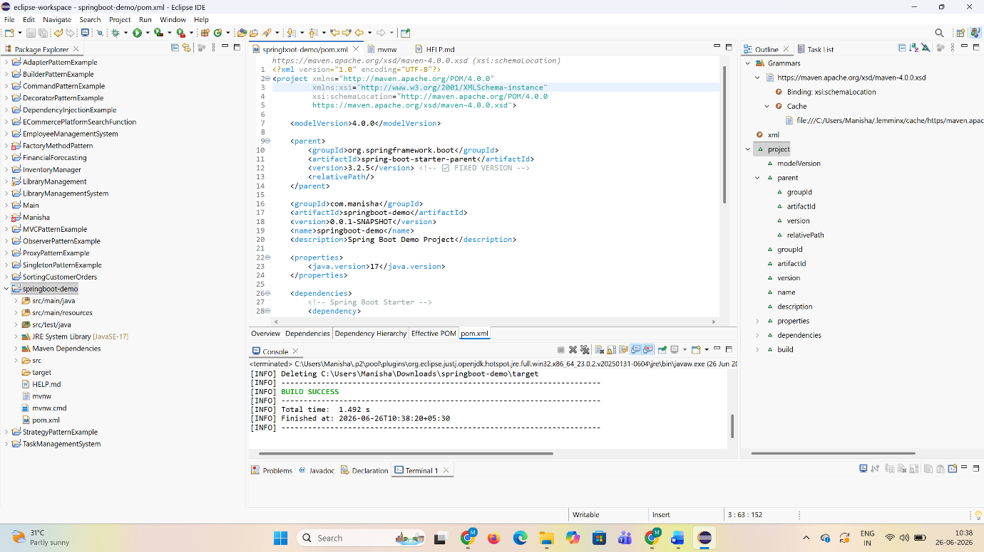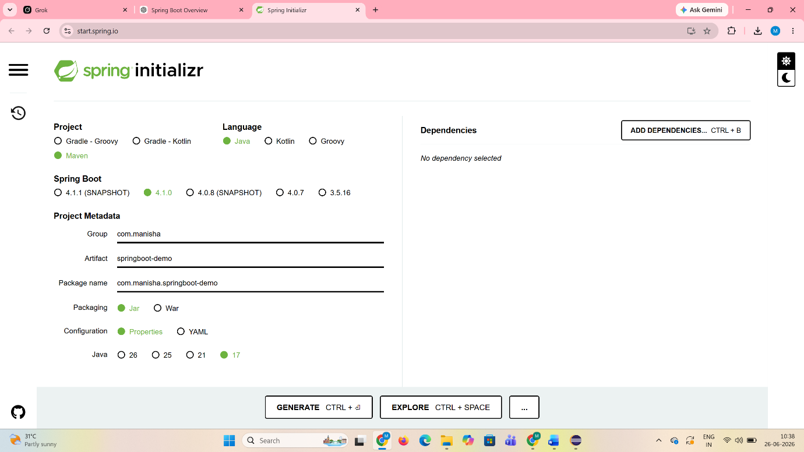

- Explain the need and benefits of Spring Boot
  - Makes Java development easy, avoids tedious development steps, reduces development time, avoids writing boilerplate code, provides embedded tomcat server, avoid XML configuration
    - Ref - https://www.journaldev.com/7969/spring-boot-tutorial

Traditional Spring development requires:
- Extensive XML configuration
- Manual dependency setup
- External server deployment

Benefits of Spring Boot:
- Simplifies Java development
- Reduces boilerplate code
- Provides auto-configuration
- Embedded servers (Tomcat, Jetty)
- No need for XML configuration
- Faster development & deployment
- Production-ready features (metrics, health checks)

- Demonstrate loading bean from spring configuration file
  - Spring configuration xml, spring xml schema spring-beans.xsd, <bean>, id, class, <constructor-arg>, <property>, name, value, ClassPathXmlApplicationContext, ApplicationContext, context.getBean(), singleton scope, prototype scope
    - Ref - https://docs.spring.io/spring-framework/docs/current/spring-framework-reference/core.html
    - IoC Container - https://docs.spring.io/spring-framework/docs/current/spring-framework-reference/core.html#beans
    - Scopes - https://docs.spring.io/spring-framework/docs/current/spring-framework-reference/core.html#beans-factory-scopes
    - Constructor Injection - https://docs.spring.io/spring-framework/docs/current/spring-framework-reference/core.html#beans-constructor-injection
    - Setter method injection - https://docs.spring.io/spring-framework/docs/current/spring-framework-reference/core.html#beans-setter-injection

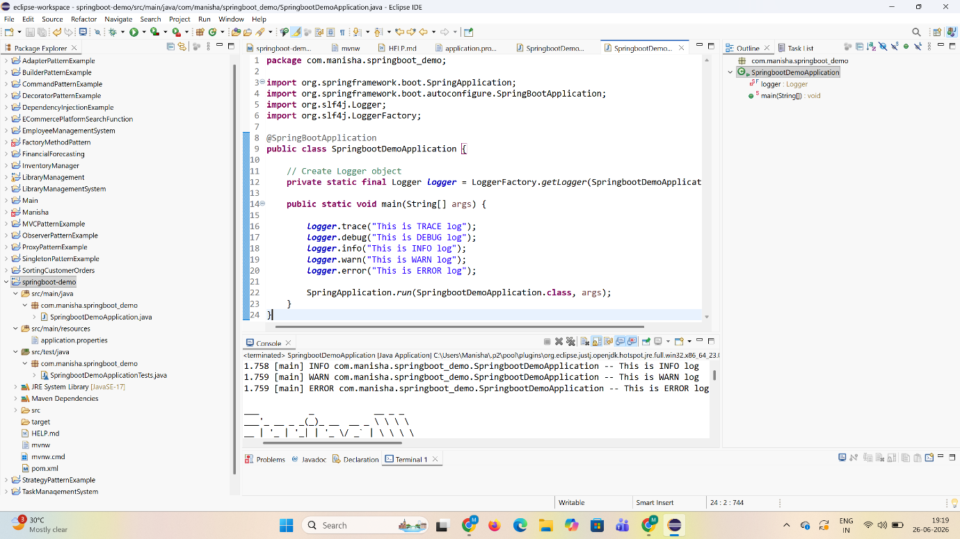
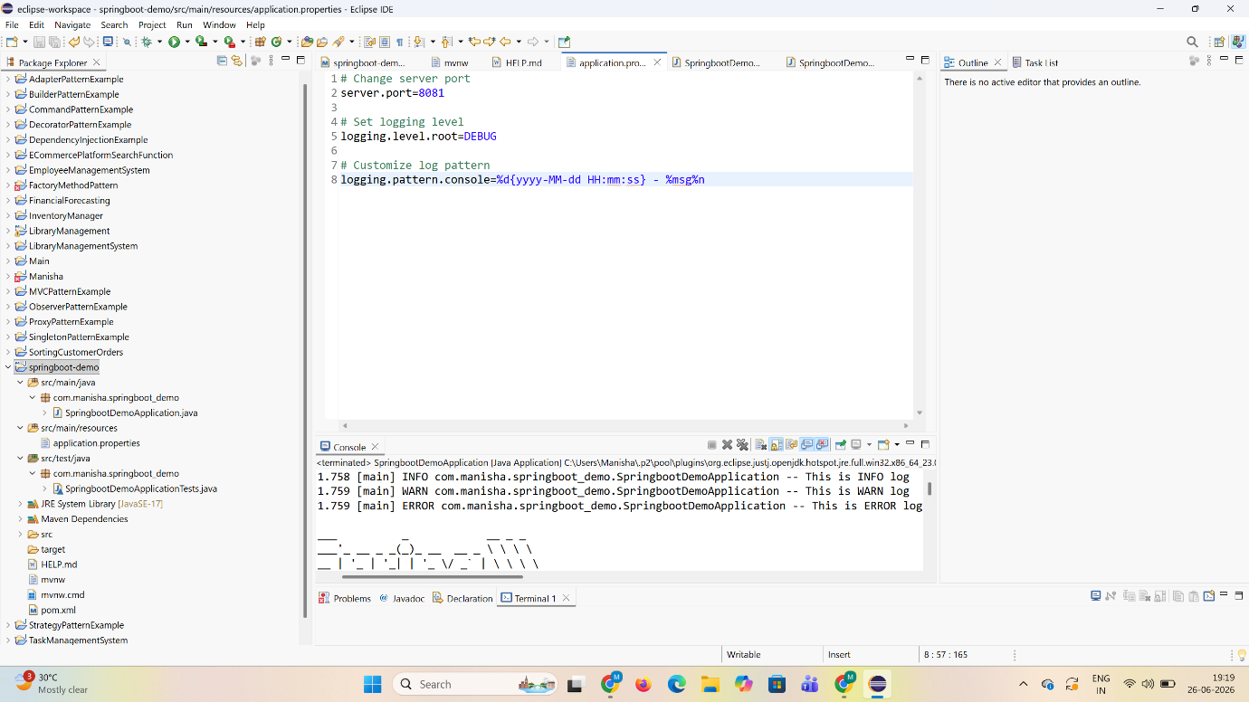

- Demonstrate inclusion of logging in Spring Boot Application
  - application.properties, logging.level, logging.pattern, server.port, LoggerFactory, Logger, log levels (trace, debug, info, warn, error)
Ref - https://docs.spring.io/spring-boot/docs/current/reference/html/boot-features-logging.html
